Data Warehousing and NoSQL

Crystal Combs, Matt Luc, Jonathan Quilliams, Charles Wigle

April 26, 2017

CSCI 3020 – 001

Dr. Bennett

*When in the course of Beta University’s events, it becomes necessary for its Development Office to seek and obtain donations from a variety of donors.*

To help the Development Office in their annual fundraising, Suzanne Hayes of Beta University called upon us to create a database for tracking donors, events, employers, donations, and payments. These and other tables would replace the spreadsheet currently keeping track of pledges and donations. Along with creating a database and inserting mock data, we created procedures printing out reports including an annual report to donors, an internal monthly report, a Phonothon Contact List, and a report displaying information on employers which match donors’ donations.

Shortly after completion of the reports, it was decided to discuss the future of the project: addition of data warehouse and NoSQL.

**Data Warehouse**

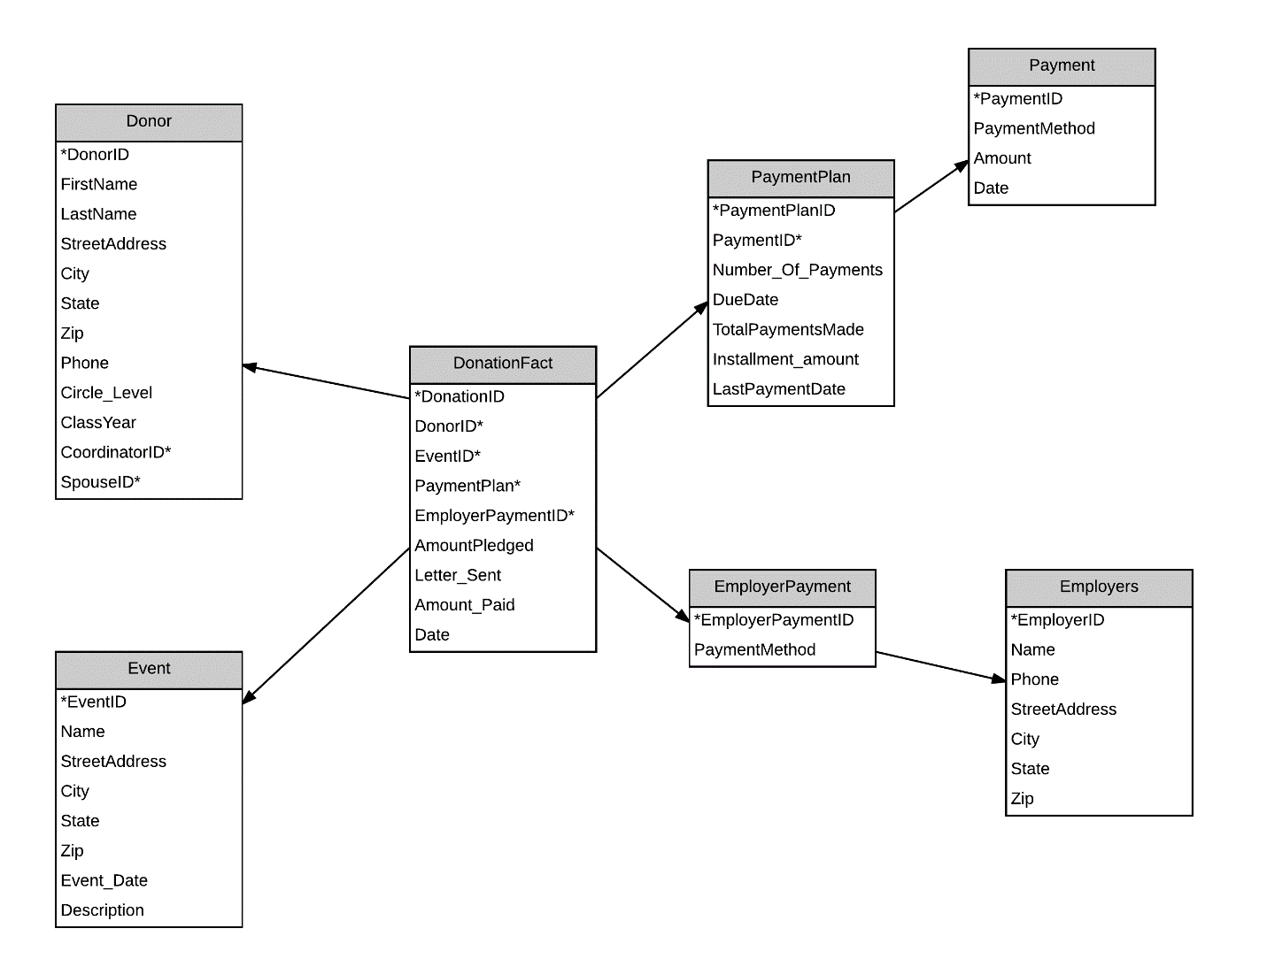

Fig. 1 – Data Warehouse Design

Holding the Phonothon Event is one reason for our need of a data warehouse. Due to the static number of volunteers and previous donors for event(s), having a specific data mart for volunteers would protect the data in two ways. Volunteers do not need access to the entire database, so a data mart would be extenuatable. And unlike skimming through an irreplaceable spreadsheet, with a data warehouse there can be security concerning data retention and reducing possible data loss.

A data warehouse would also be appropriate for donor data analytics, as we also believe there are trends to be found within the donation historical data. For example, keeping track of Employers and Donors, we can determine which companies would be best suited for soliciting donations from, through its employees. Furthermore, we can tell when to better hold an event so as to get a better amount of donations both numerically and fiscally.

ETL

**NoSQL**

Now after deciding to use a data warehouse, this leaves the question as to whether decide on a SQL or NoSQL option of database.

Pros of MongoDB: Helpful when it comes to data retention. Use this as the Data Warehouse.

Cons of Mongo DB: Takes time to learn if switching from

**Conclusion**

We believe a data warehouse and NoSQL for our project to be good investments. A Data warehouse is good because we are using for both the Phonothon event and data analytics. The use of a NoSQL server as would mean better storage and data retention. It also gives flexibility when it comes to adding new fields to records in the near future.